**Java Programming IN2203-G2 2021W Assignment 2**

Dropbox location to upload this sheet to: <https://www.dropbox.com/request/ovjW7KbBB5PMiUjqojec>

(First: Rename this sheet as TeamName-G1-Assignment2.docx)

Assignment 2: You can work in teams of up to 5 people:

How you will hand this work in:

Start by downloading this sheet.

Make up a Team Name (i.e., TheAmazingPeanut)

Rename this sheet as TeamName-G1-Assignment2.docx

*Purpose of Assignment 2:*

Learn how to hook up a sqlite Database to your Java Code.

This Assignment will provide a Java Application to connect “program space” to an external SQL database.

Fill out this table:

|  |  |
| --- | --- |
| Names and Student ID of all team members: |  |
| Name your GITHUB REPO Private  Send an Invitation to Peter Sigurdson  Present your Invitation Link to me, here: | <https://github.com/computationalknowledge/TeamPeanutIN2203g2Assignment-2/invitations> |
|  |  |
|  |  |

**Grading Rubric:**

This work will be graded on a Scale of 100 Points:

|  |  |
| --- | --- |
| 25 points | The work is handed in on time by Midnight March 27, 2021  You have uploaded this Sheet, properly filled out and named as your Team Name: to this Dropbox LINK:  <https://www.dropbox.com/request/ovjW7KbBB5PMiUjqojec>  You have properly put your Code into a PRIVATE Github Repository and submitted an Invitation to Peter Sigurdson |
| 25 points | Make extensive use of COMMENTS to describe what you are doing in your code and why.  In your Main File, you should have comments indicating Team Member’s Names and Student IDs. |
| 25 points | I would like to see frequent GITHUB commits as a proof that your team developed the work by themselves. |
|  |  |

**All you need is sqlite3.exe**

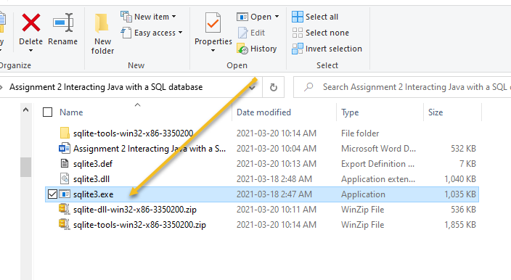

**Learning Outcomes:**

|  |
| --- |
| Transacting data in and out of our program with a SQL Database |

Download and play with https://sqlitebrowser.org/

**Resources:**

Code Snippets: <https://www.demo2s.com/>

**Using SQLITE:** [**https://www.tutorialspoint.com/sqlite/sqlite_java.htm**](https://www.tutorialspoint.com/sqlite/sqlite_java.htm)

**Download SQLITE: https://sqlite.org/download.html**

**Using GitHUB to create a private Repository and send an Invitation LINK:**

<https://youtu.be/qdBHwD8StMU>

Video on using sqlite:

<https://youtu.be/p_hd30R25bI>

**The purpose of A2 is connect our Java Program space to sql database**

**Project = Make a monopoly game!**

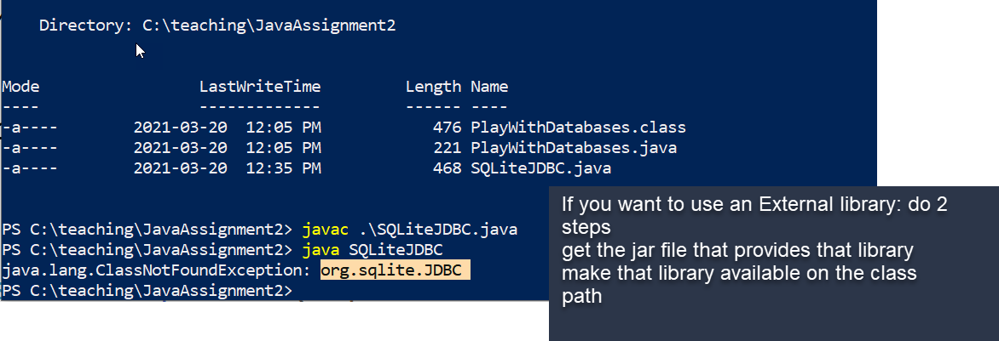

**JDBC is the Java Database Connectivity library**

**Jar file : Java Archive Resource**

**Download the sqlite JDBC JAR file**

**You need to put 2 files in the directory where your Java Code is:**

# Pull down these assets:

1. You need the sqlite exe file because that is the database engine
2. You need the JAR java archive resource file that provides the Java Library code that lets your Java code talk to sqlite

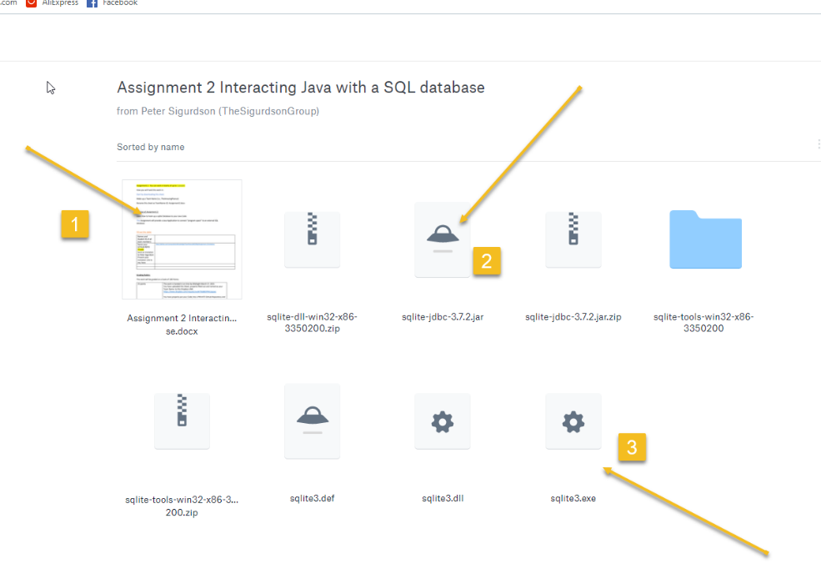

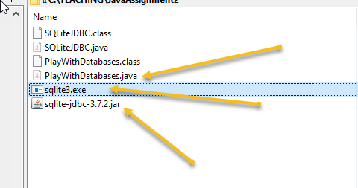

**I need 3 files to make my Java Application work:**

1. **I need my program that I am writing**
2. **sqlite exe – the database engine**
3. **I need the JDBC for sqlite jar file** 
   1. **JDBC Java Database Connectivity**

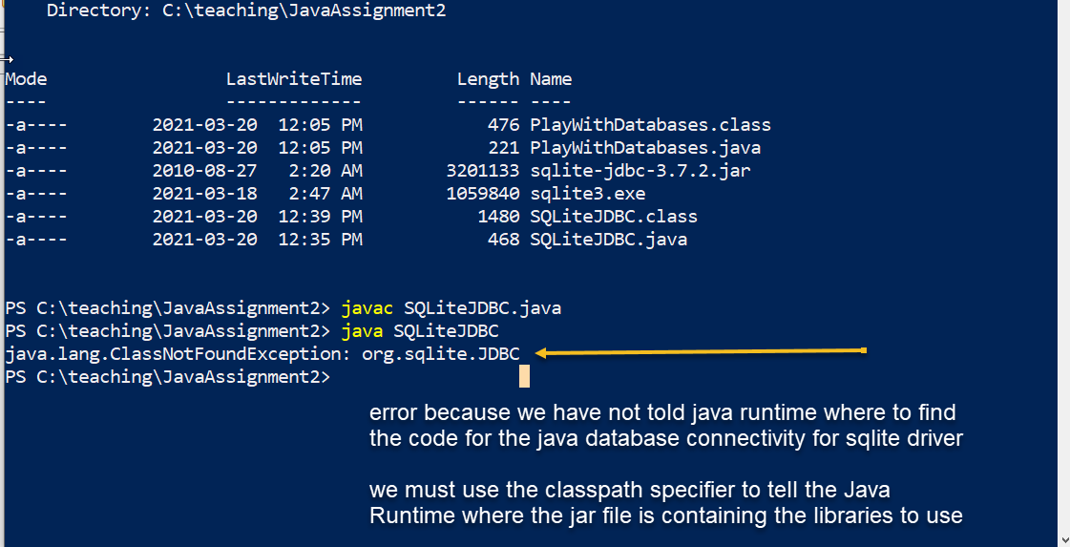



**JDBC is the Java Database Connectivity library**

**Jar file : Java Archive Resource**

**Download the sqlite JDBC JAR file**

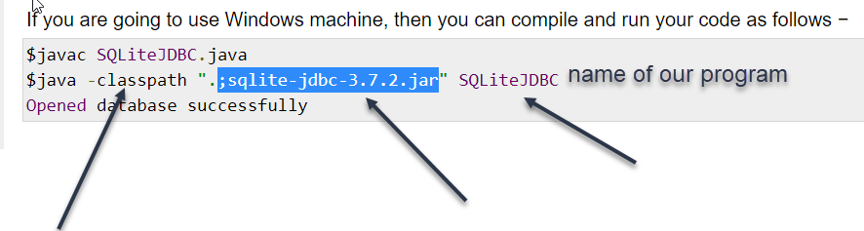

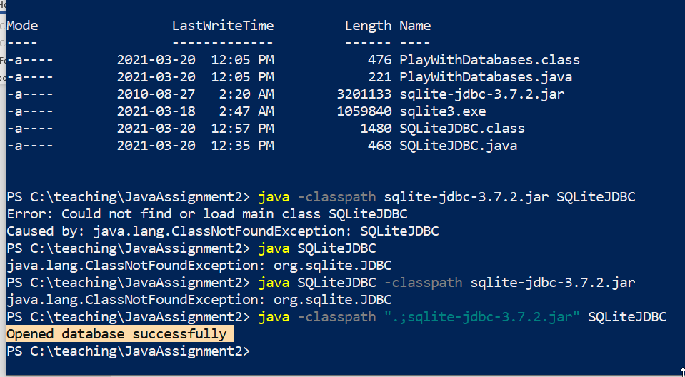

You can get starter code from my Github:

https://github.com/computationalknowledge/TeamPeanutIN2203g2Assignment-2

*How to get started:*

**Step 1:**

Let’s construct a Simple Java Application that can communicate with a SQL Database.

Start by making a Directory and a File to put your Code into.

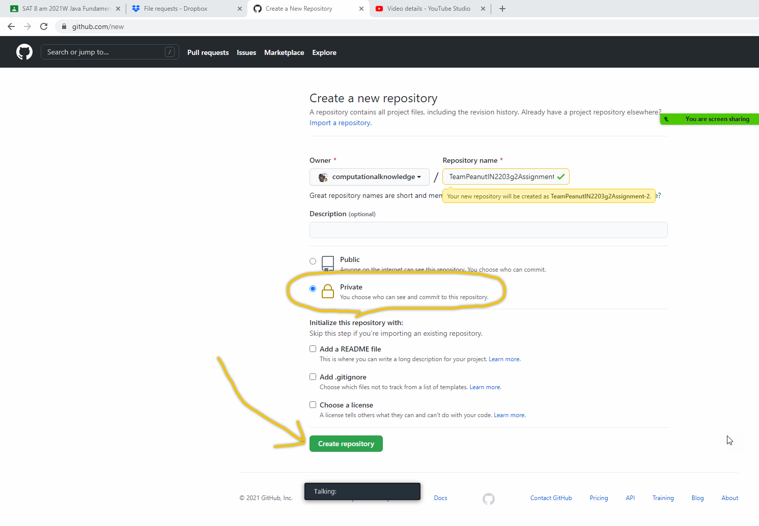

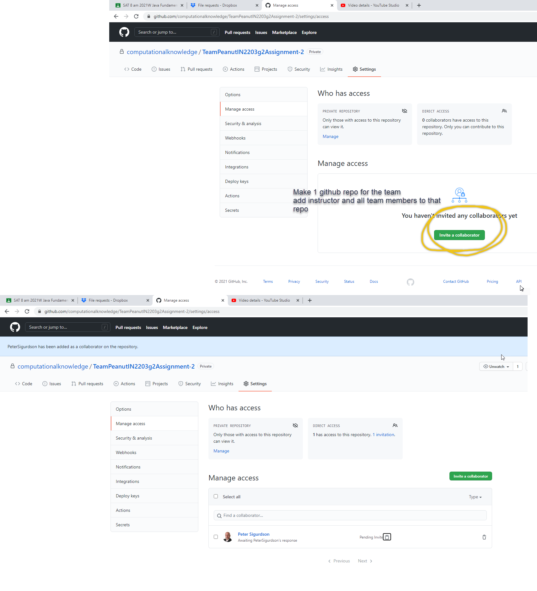

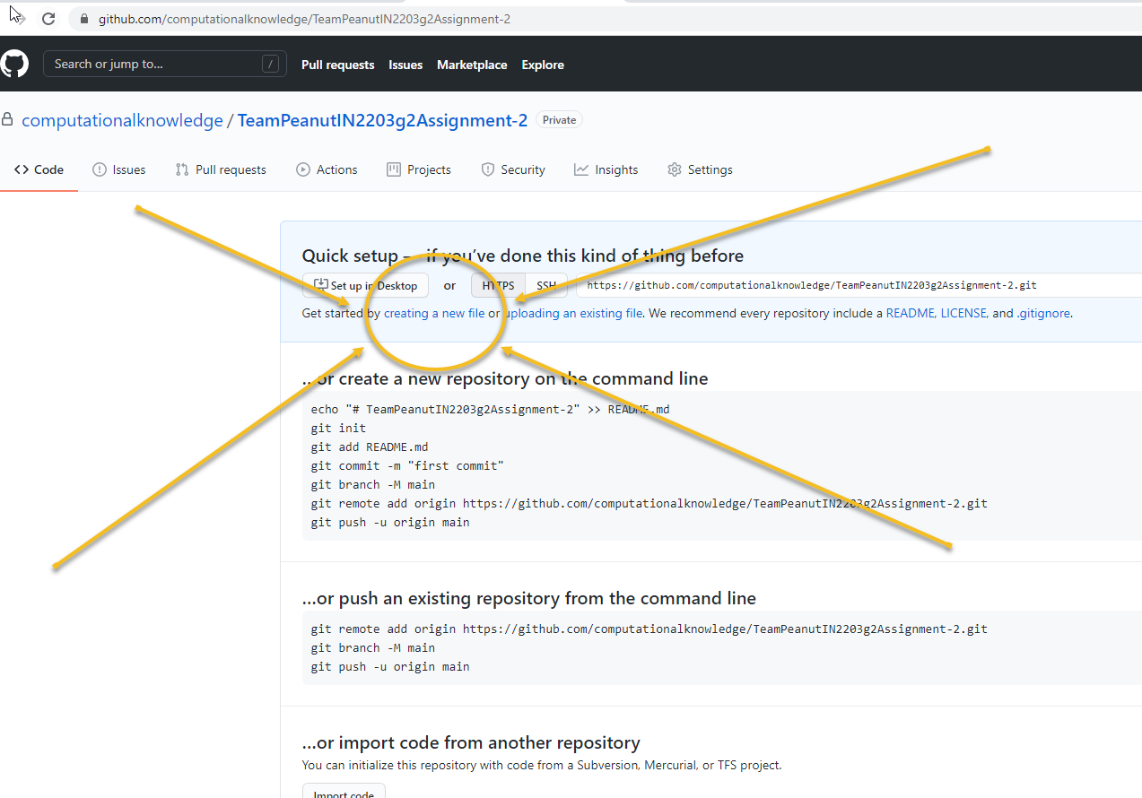

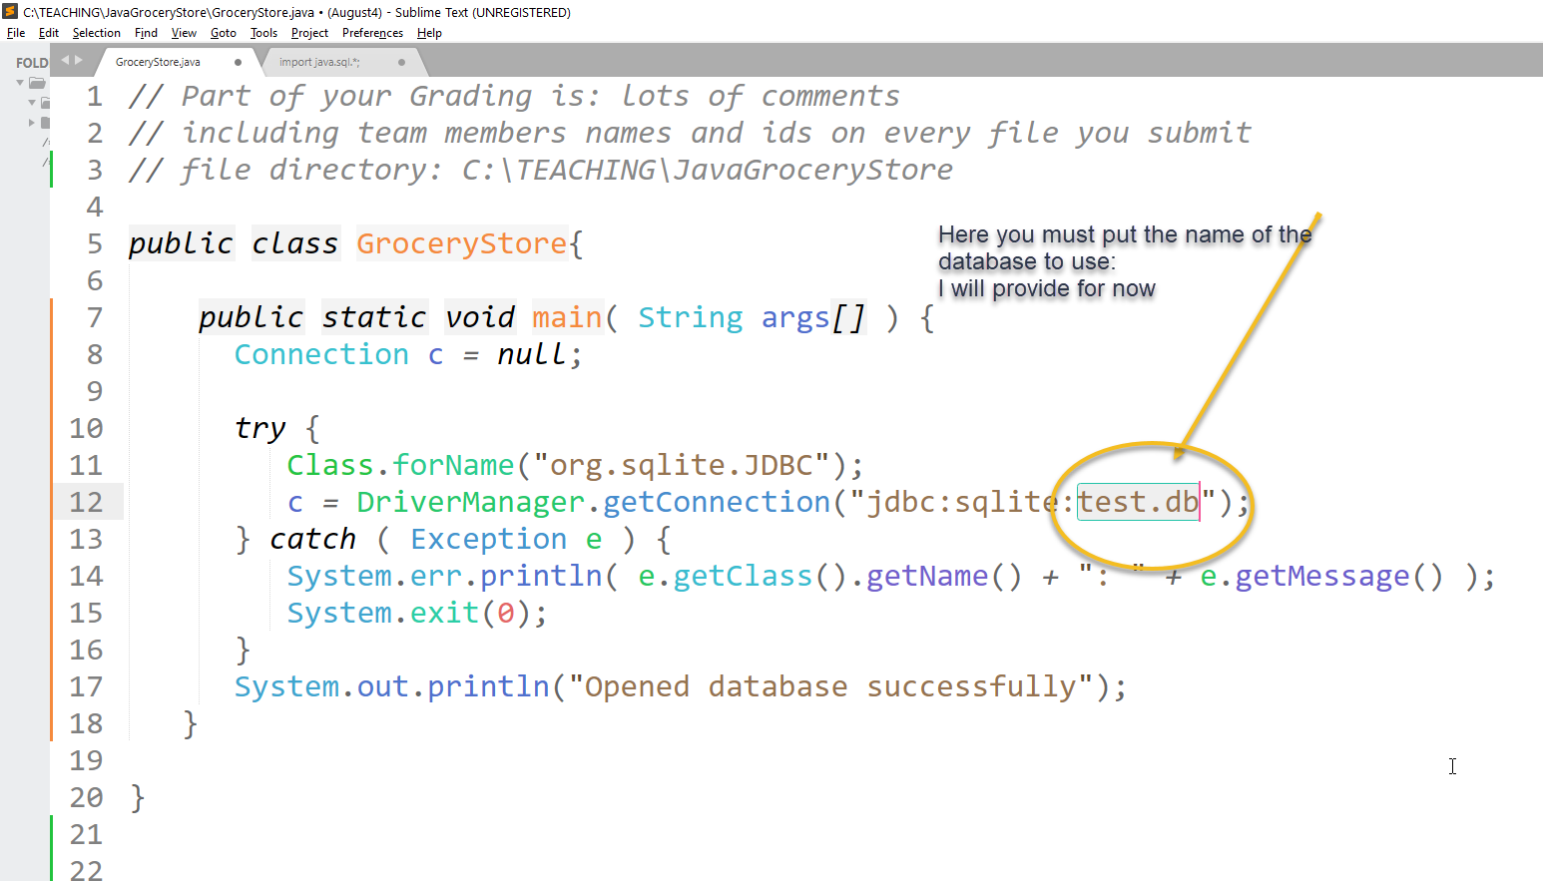

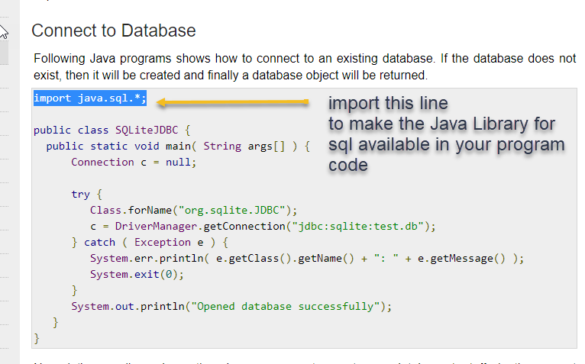

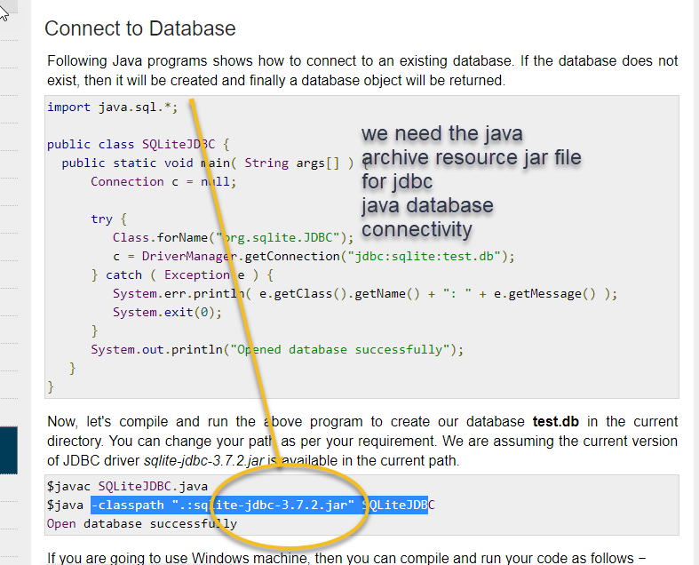

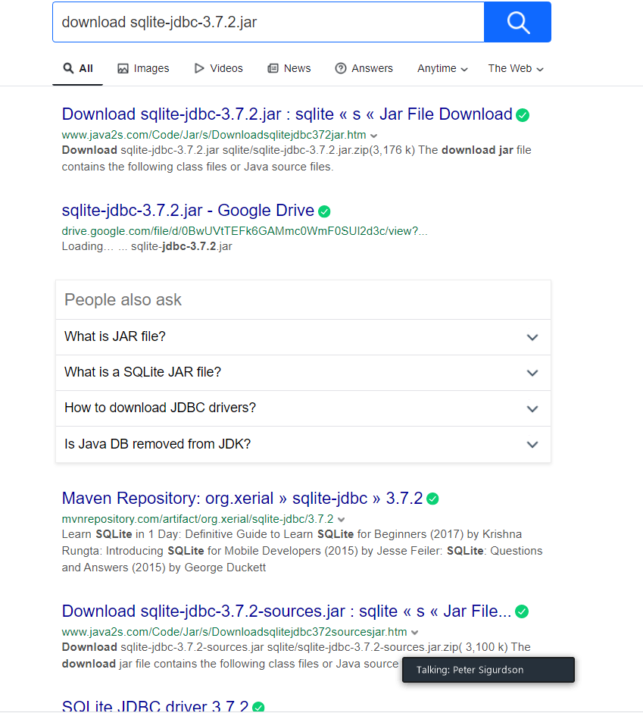

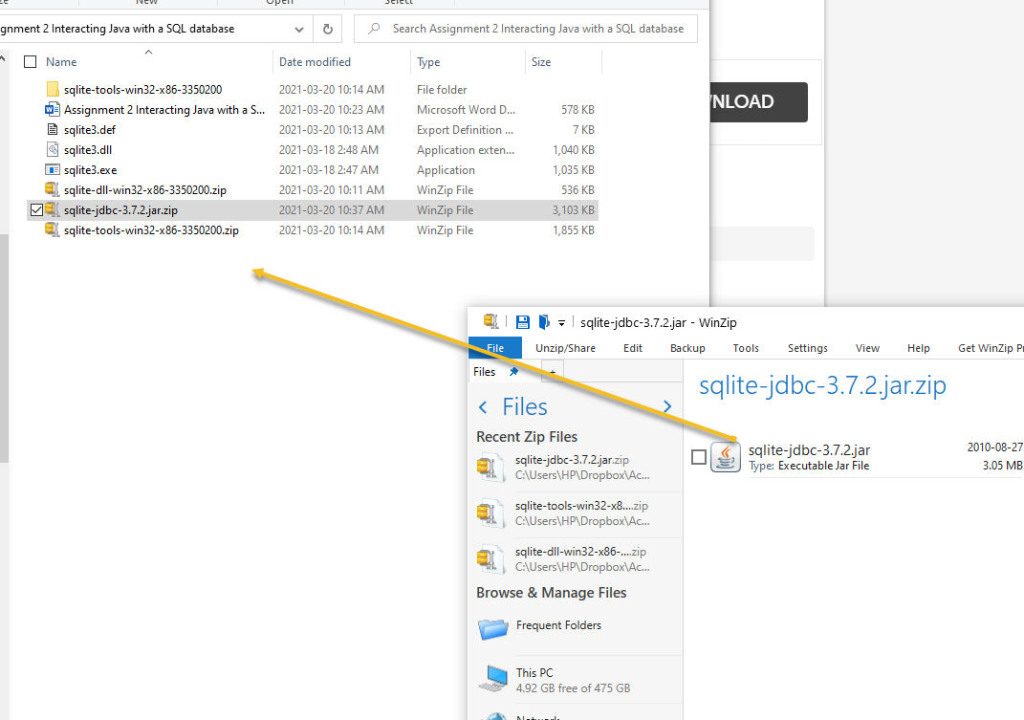

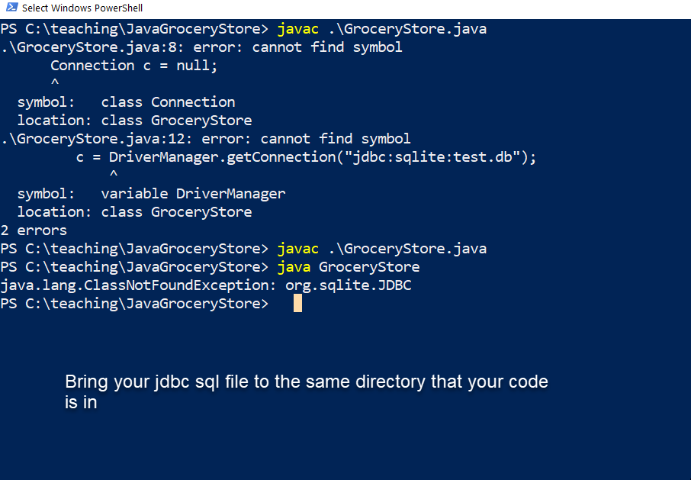

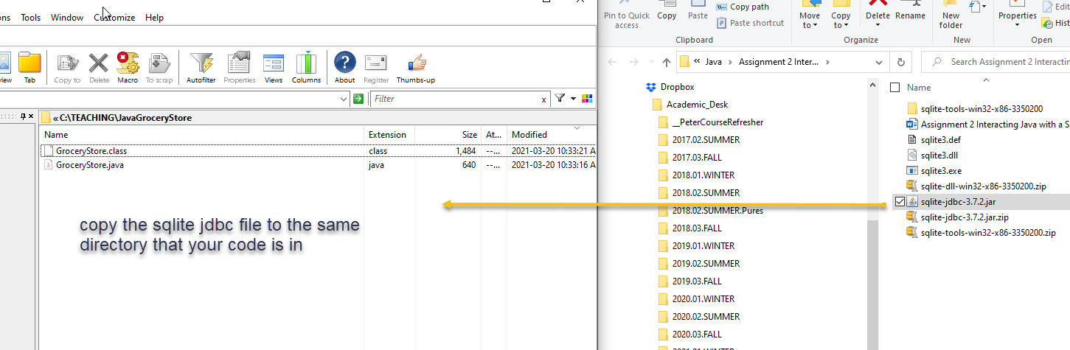

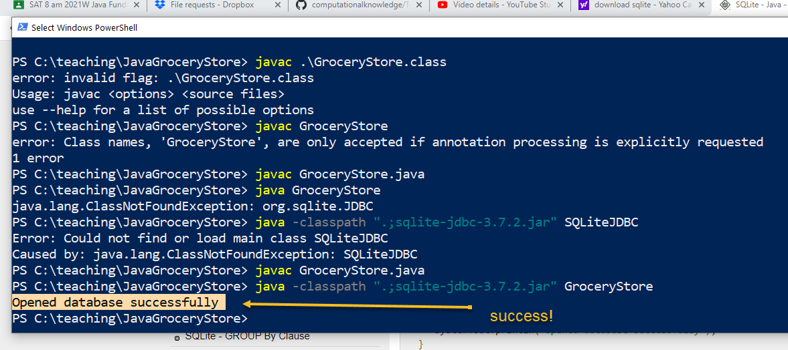

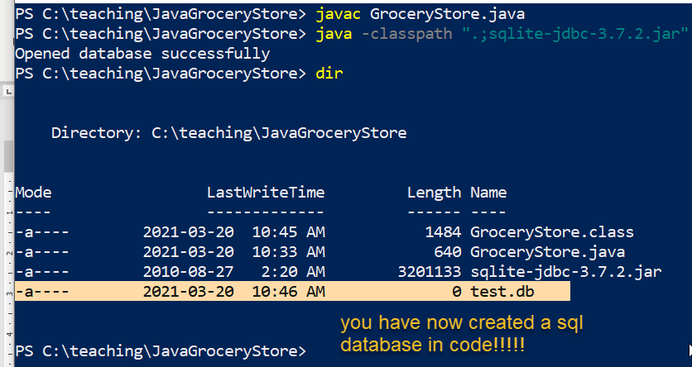

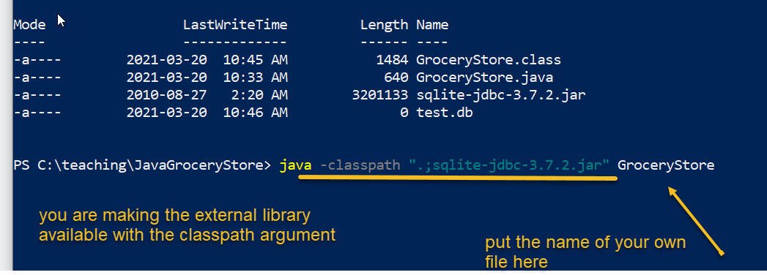

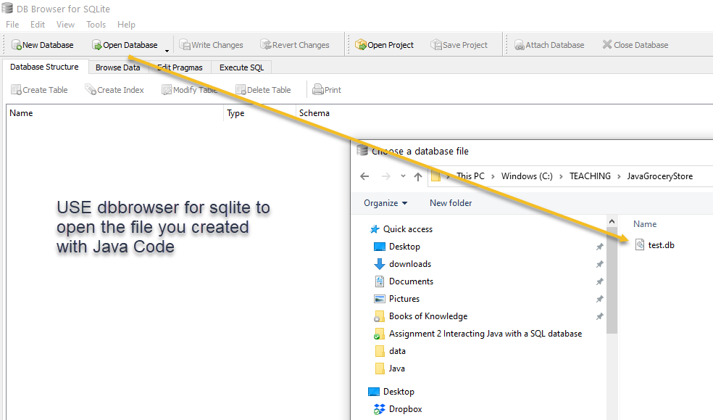

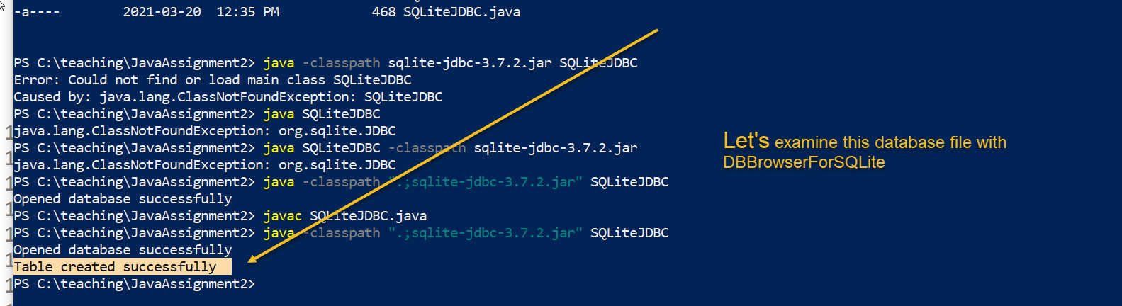

# A tutorial on SQL:

